
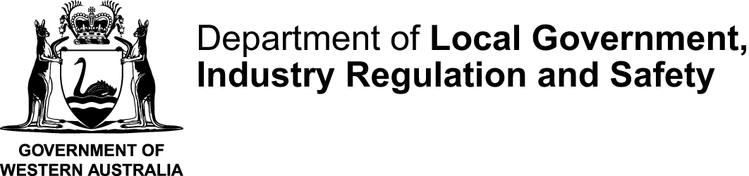
FORM 09R |  | This form is effective from 1 July 2026
Application for replacement certificate of incorporation
Associations Incorporation Act 2015 s20
Please read this information before completing this form
ABOUT THIS FORM
Use this form to obtain a replacement certificate of incorporation under the Associations Incorporation Act 2015.
DO NOT use this form to request a duplicate certificate, extract, or copy of the rules. Instead use the Form 09.
HOW TO COMPLETE THIS FORM
- You may complete this form onscreen and then print it, or print it first and complete it by hand.
- If completing by hand, please use a blue or black pen and write in BLOCK LETTERS
RELATED INFORMATION
A Replacement Certificate can only be issued if the original certificate has been lost or is destroyed.
If the original certificate has NOT been lost or destroyed and you need confirmation of the association’s current status, you can purchase Extract.
- An Extract contains the associations current name, registration number (IARN), date of incorporation or cancellation (if applicable), status, Address for service of notice., tier classification, financial year end, date of last annual general meeting and type of rules used.
FEE
Please refer to Associations fees forms and online transactions page for current application fee. GST is not payable on this fee. If you lodge this form by post or email, you will be emailed a Payment Number (PN) to make payment by BPAY or a credit card through our secure online payment portal.
HOW TO LODGE
You can lodge your completed form:
In person: |  |  | By post: | Email:
Customer Service  Level 1, Mason Bird Building  303 Sevenoaks Street, CANNINGTON  Hours: 8:30 am to 4:30 pm (weekdays) |  |  | Associations and Charities  Department of Local Government, Industry Regulation and Safety  Locked Bag 14  CLOISTERS SQUARE PERTH WA 6850 | associations@lgirs.wa.gov.au
WHAT HAPPENS NEXT
- The replacement certificate will be issued digitally and sent by email to the contact person nominated in this application. Documents are usually issued within 10 working days.
- You will be notified if a replacement certificate cannot be issued.
CONTACT
Telephone | 1300 30 40 74 or (08) 6552 9300 (8:30 am to 4:30 pm weekdays)
Email | associations@lgirs.wa.gov.au
Website | www.lgirs.wa.gov.au/associations

FORM 09R
Application for replacement certificate of incorporation
Associations Incorporation Act 2015 s20
OFFICE USE ONLY

SECTION A: REQUEST DETAILS
Incorporated association’s name |  |  |  |  |  |  |  |  | IARN
The reason for requesting the replacement certificate is due to the original certificate being:
 | Lost or stolen
 | Destroyed or damaged
SECTION B: AUTHORISED PERSONS PARTICULARS & DECLARATION
Provide the name and particulars of the person making this application:
I declare that:
- I am authorised by the association's committee to lodge this application under the Associations Incorporation Act 2015;
- The association’s original certificate of incorporation has been lost, stolen or destroyed.
- The information contained within this application is to the best of my knowledge true and correct.
- I understand that it is an offence under section 177 of the Associations Incorporation Act 2015 to make a false and misleading declaration in relation to this application

Signature |  |  |  |  | Date signed
Title |  |  | Mr Mrs Ms Miss Other, please specify: _____________________________
Name |  |  |  |  | Surname
Address
(Street or PO)
Suburb |  |  |  | State |  | Postcode
Email |  |  |  |  | Telephone
IMPORTANT: Before you sign this form, check that you have provided true and correct information.

FORM CONTINUES GO TO NEXT PAGE

CONTACT FOR THIS APPLICATION
 | Who should Consumer Protection contact if there is a query about this application form?
 |  | The applicant (submitter)
 |  | Another person Provide the contact’s details below:
 | Title |  | Mr Mrs Ms Miss Other, please specify: ___________________________
 | Name |  |  |  | Surname
Address
(Street or PO)
 | Suburb |  |  | State |  |  | Postcode
 | Email |  |  |  | Telephone

