
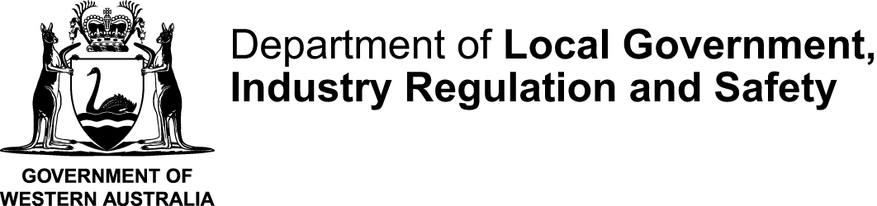
STCMTMEM |  |  | This form is effective from 1 July 2026
Certificate and statement of a committee member form to accompany Form 6N
Associations Incorporation Act 2015 s 30
INSTRUCTIONS:
Only complete this statement if the person lodging the application for voluntary cancellation (Form 6N) is not a member of the management committee
 | Name of incorporated association
 | Incorporated Associations Registration Number (IARN)
 | The special resolution(s) approving the application to cancel the association’s incorporation and a distribution plan for its surplus property, if applicable, were passed on:
 |  |  |  | (dd/mm/yyyy)
 | DECLARATION
 | I hereby certify that:
 | ☐ | I am a duly elected member of the management committee of the incorporated association named above
 | ☐ | I confirm that the following person is authorised to prepare and lodge the application for voluntary cancellation on behalf of the incorporated association:
 |  | _________________________________________________________________________________
 |  | (insert full name of authorised person)
 | ☐ | The management committee has examined the association’s affairs and resolved that its debts and liabilities either:  - have been satisfied, and there is no surplus property to be distributed; or  - are able to be paid or met, and after payment there is surplus property to be distributed;
 | ☐ | A special resolution to cancel the association’s incorporation was passed by members at a general meeting convened in accordance with the association’s rules and the requirements of the Associations Incorporation Act 2015.
 | ☐ | The distribution plan, if any, included in the accompanying Application for voluntary cancellation form was approved by special resolution of the association’s members
 | ☐ | The information provided in the accompanying Application for voluntary cancellation of incorporation” form is, to the best of my knowledge and belief, true and correct.
 | Signature |  |  |  |  |  | Date signed
 | Full name of committee member signing this form
 | Position held
 | Daytime telephone number |  |  |  |  | Email
PRIVACY COLLECTION NOTICE
The Department of Local Government, Industry Regulation and Safety (LGIRS) collects the personal information you provide through this form to administer the Associations Incorporation Act 2015 (WA), including assessing applications, processing notifications and maintaining regulatory information. For more information about how your personal information is handled, including disclosures and your privacy rights, please see the full Privacy Collection Notice on our website.

