
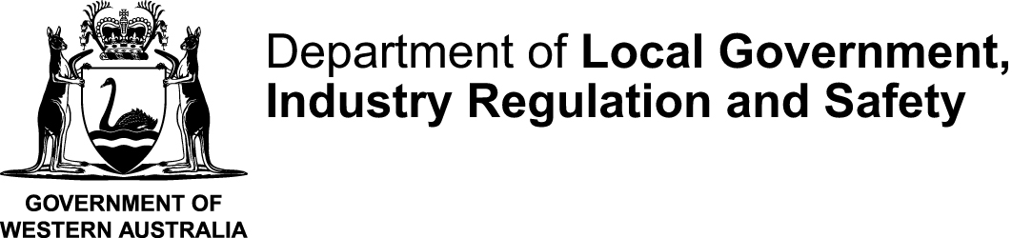
Application for Street Collection within Perth Metropolitan Area or lodge a street collections statement
Street Collections (Regulation) Act (1940)
Application information sheet
This form is used by organisations to apply for permission to collect funds in a public street or thoroughfare in the Perth Metropolitan area under the Street Collections (Regulations) Act 1940 (the Act)
What is a street collection?
A street collection is the ‘soliciting of funds or contributions and the selling and offering for sale of any button, badge, token, or other similar thing for the purpose of raising funds or contributions’ in a public street or thoroughfare.
Any organisation wanting to conduct a street collection in Perth metropolitan area for any purpose must have a street collection permit.
Before submitting your application for a street collection permit, please review the following considerations and refer to the Street Collection guidelines available on the website.
What days can we collect?
- The Street Collections (Regulation) Act 1940 only allows for fifty days to be allocated each year for street appeals.
- Street collections will generally only be allowed to be conducted on a Friday, though occasional exceptions may be made for National day or special events.
- Due to the limited number of days allocated for street collections generally only one appeal is allowed for each applicant per year.
- A roster of all currently approved street appeals is available at www.consumerprotection.wa.gov.au/charities. You may wish to refer to this roster to see which other organisations may be collecting on your proposed appeal date.
Collectors:
- Each collector must wear a badge showing the name of the organisation.
- A collector must not annoy or intimidate anyone and cannot obstruct a public street.
- A child under 16 (but not pre-school or primary school age) may be given approval to collect if written approval has been given by the Minister's delegate. They must operate in pairs and be always accompanied by an adult during the collection.
- No payments or reward shall be given directly or indirectly to any collectors in connection with the street collection, except with prior special approval by the Minister.
Collection locations:
- Collections can be made from the public in any street, roadway, mall or lane in the Perth Metropolitan area.
- Collectors may also need to obtain permission from the local council for the locality that you intend to collect in.
- Collecting on private property, such as shopping centres is not covered by the permit and approval must be obtained from the owner of the property or shopping centre manager to collect on these premises.

When can we collect?
- The Department requires at least two weeks’ notice to issue a street collection permit.
- If the application for a street permit is approved, a written permit will be issued to the Organisation. The appeal may only be conducted on the date and time specified by this permit.
Street collections statements
- Once the street collection has been undertaken, the permit holder is required to lodge a Street Collections Statement settling out the amount of money raised, and the expenses incurred. The statement must be lodged within 30 days of the collection.
How to lodge this form
- Type directly into this form electronically before printing and signing it or hand print neatly using an ink pen in block letters.
- Tick where appropriate and attach additional pages if space in this form is insufficient.
- Return this completed form together with any attachments by email to charities@lgirs.wa.gov.au. Please retain a copy of this form for your records.

If you need assistance completing this form, contact the Associations and Charities Branch on (08) 6552 9364.

Application for Street Collection within Perth Metropolitan Area
Street Collections (Regulation) Act (1940)
- ORGANISATION CONTACT DETAILS
Organisation Name:
Postal address:
Suburb: |  |  |  |  | State: |  |  |  | Postcode:
Telephone: |  |  |  |  | Email:
- APPLICATION FOR STREET COLLECTION WITHIN PERTH METROPOLITAN AREA
Date Preferred: |  | 1st Preference
 |  | 2nd Preference
Which locality or localities will the collection be made in?
What is the objective or purpose for which it is proposed to raise funds:
Will anyone under the age of 16 be participating in the street collection? |  |  |  |  |  |  |  |  | ☐ Yes |  |  | ☐ No
Do you proposed to pay any persons for being a collector, or any other person assisting in the collection? |  |  |  |  |  |  |  |  | ☐ Yes |  |  | ☐ No
- APPLICATION SIGNATORY AND DECLARATION
I hereby certify that I am authorised to apply for a permit to conduct a street collection on behalf of the organisation and the information provided on this form is true and correct.
First Name |  |  |  |  |  |  | Surname
Role with the organisation:
Signature (Do not Print) |  |  |  |  |  |  |  |  | Date:

