
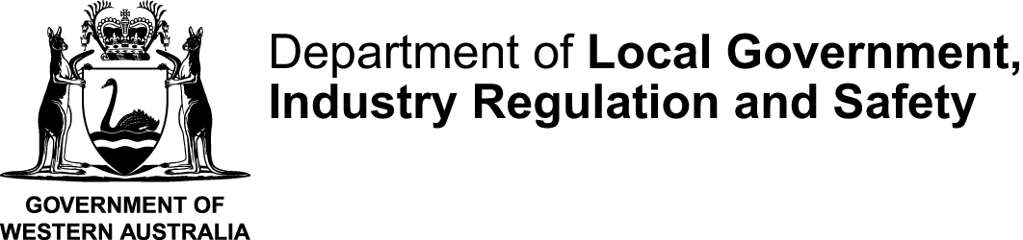
STCMTMEM |  |  | This form is effective from 1 July 2025
Certificate and statement of a committee member form to accompany Form 6N
Associations Incorporation Act 2015 s 30
OFFICE USE ONLY

INSTRUCTIONS:
Only complete this statement if the person lodging the application for voluntary cancellation is not a member of the management committee
 | Name of incorporated association
 | Incorporated Associations Registration Number (IARN)
 |  |  |  | (If you do not know the number search for it using AssociationsOnline)
 | Date of the general meeting where a special resolution approving the voluntary cancellation and distribution plan (if applicable) was passed:
 |  |  |  |  |  |  |  | (dd/mm/yyyy)
 | DECLARATION
 | I hereby certify that:
 | ☐ | I am a duly elected member of the management committee of the incorporated association named above
 | ☐ | I confirm that the following person is authorised to prepare and lodge the application for voluntary cancellation on behalf of the incorporated association:
 |  | _________________________________________________________________________________
 |  | (insert full name of authorised person)
 | ☐ | The management committee has examined the incorporated association’s affairs and resolved that it has met or is able to meet its debts and liabilities.
 | ☐ | A special resolution to apply for voluntary cancellation was passed by members at a general meeting convened in accordance with the association’s rules and the requirements of the Associations Incorporation Act 2015.
 | ☐ | If applicable, a plan for the distribution of the surplus property was approved by special resolution at the same general meeting
 | ☐ | The information provided in the accompanying “Form 6N - Application for voluntary cancellation of incorporation” form is, to the best of my knowledge and belief, true and correct.
 | Signature |  |  |  |  |  | Date signed
 | Full name of committee member signing this form
 | Position held
 | Daytime telephone number |  |  |  |  | Email

