
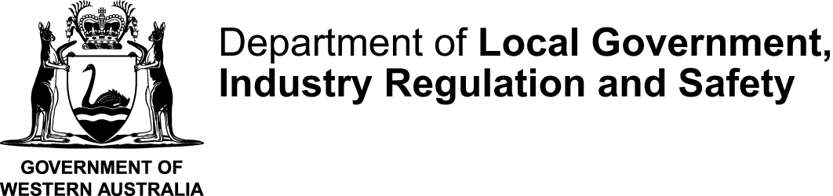
STCMTMEM |  |  | This form is effective from 1 July 2025
Certificate and statement of a committee member form to accompany Form 5
Associations Incorporation Act 2015 s 30
OFFICE USE ONLY

INSTRUCTIONS:
Only complete this statement if the person lodging a Form 5 – notice of Special Resolution to change rules is not a member of the incorporated association’s management committee
 | Name of incorporated association
 | Incorporated Associations Registration Number (IARN)
 |  |  |  | (If you do not know the number search for it using AssociationsOnline)
 | Date of the general meeting where a special resolution to change the rules was passed:
 |  |  |  |  |  |  |  | (dd/mm/yyyy)
 | DECLARATION
 | I hereby certify that:
 | ☐ | I am a duly elected member of the management committee of the incorporated association named above.
 | ☐ | I confirm that the following person is authorised to prepare and lodge the Notice of Special Resolution to change the rules on behalf of the incorporated association:
 |  | _________________________________________________________________________________
 |  | (insert full name of authorised person)
 | ☐ | The alterations to the rules covered in the “Form 5 - Notice of Special Resolution to Change rules” form was passed by members at a general meeting convened in accordance with the association’s rules and the requirements of the Associations Incorporation Act 2015..
 | ☐ | The information provided in the accompanying “Form 5 – Notice of Special Resolution to Change rules” form is, to the best of my knowledge and belief, true and correct.
 | Signature |  |  |  |  |  | Date signed
 | Full name of committee member signing this form
 | Position held
 | Daytime telephone number |  |  |  |  | Email

