
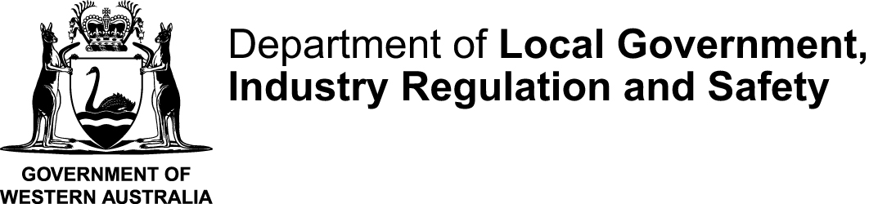
Form 4 | This form is effective from 1 July 2025
Notification of an incorporated associations address
Associations Incorporation Act 2015 s7, 103, 174 and 203
Please read this information before completing this form
ABOUT THIS FORM
Use this form to give notification under the Associations Incorporation Act 2015 to Consumer Protection about the following changes to your incorporated association:
- address
- address for service
- email address
Lodgement period
This form must be lodged within 28 days of the change occurring. Penalties may apply for failing to give notification within required timeframe.

HOW TO COMPLETE THIS FORM
- You can complete this form onscreen and print it out or print and complete by hand.
- If completing by hand use a blue or black pen and print using BLOCK letters.
- Complete all sections of the form.
RELATED INFORMATION
- Incorporated associations must notify Consumer Protection of any changes to their contact address, address for service, or email address within 28 days of the change.
- The Address is used for posted correspondence and should be an address used by the public.
- The Address for service is used for the delivery of official and legal documents. It may be the same as or different from the associations address.
  - This address is published on Extract’s from the Register, which may be purchased by members of the public.
- The Associations email address should be an email that is regularly monitored and accessible by one or more members of the management committee.
- Keeping your association’s details up to date ensures you receive important communications and remain compliant with the Act.
FEES
There is no fee to submit this form

HOW TO LODGE
Once you have completed this form, you can lodge it using one of the following methods:
By email: |  | associations@lgirs.wa.gov.au
By post |  | Department of Local Government, Industry Regulation and Safety  Associations and Charities  Locked Bag 14  CLOISTERS SQUARE PERTH WA 6850
WHAT HAPPENS NEXT
- We will review our form and contact you in writing if further information is needed.
- If the form is completed correctly, the information will be recorded on the Register of Incorporated Associations.
- This form may not be processed if it is incomplete or is incorrectly completed.
PRIVACY
Consumer Protection at the Department of Local Government, Industry Regulation and Safety (LGIRS) is collecting and holding information supplied for the purposes of the Associations Incorporation Act 2015 (the Act).
In accordance with the Act, a copy of this form and any documents lodged with will be available for inspection and purchase by the public upon payment of a prescribed fee. In other instances, information on this form can be disclosed without your consent where authorised or required by law.
CONTACT
For assistance with completing this form, or information about the progress of an application, contact the Associations and Charities Branch by:
Telephone | 1300 30 40 74 or (08) 6552 9300 (8:30 am to 4:30 pm weekdays)
Email | associations@lgirs.wa.gov.au
Website | www.lgirs.wa.gov.au/associations

The above information is intended as a guide only and is included to assist you in completing and lodging this form. This page is not part of the form. If required, professional advice should be obtained regarding the matters dealt with in this form

Form 4
Notification of an incorporated associations address
Associations Incorporation Act 2015 s7, 103, 174 and 203
OFFICE USE ONLY

SECTION A: INCORPORATED ASSOCIATION PARTICULARS
- What is the name of the incorporated association?
The association’s name as shown on the certificate of incorporation.
- What is the incorporated association’s registration number (IARN):
SECTION B: ADDRESS PARTICULARS
- What is the association’s new contact address?
The association’s contact address is the address for posted correspondence. This should be the address the public can use to contact the association.
Suburb |  |  |  | State |  | Postcode
- What is the association’s new email address?
The email address will be used to email correspondence to the association. This should be a generic email address or an email that the management committee have access to.
Email
- What is the association’s new address for service?
The address for service is the address that where official documents can be delivered (served) to the association.
The address for service is the same as the association’s current contact address
Suburb |  |  |  | State |  | Postcode
- Date that the changes occurred:

SECTION C: AUTHORISED PERSONS PARTICULARS & DECLARATION
Provide the name and particulars of the person making this application:
I certify that:
- I am authorised by the association's committee to lodge this application under the Act;
- I have prepared this application in accordance with the information supplied by each of the amalgamating associations; and
- I acknowledge that it is an offence under section 177 of the Associations Incorporation Act 2015 to make a false and misleading declaration in relation to this application.
Signature |  |  |  |  | Date signed
Title |  | Mr Mrs Ms Miss Other, please specify: _____________________________
Name |  |  |  |  |  |  |  | Surname
Address
(Street or PO)
Suburb |  |  |  | State |  |  |  |  |  | Postcode
Email |  |  |  |  |  |  |  | Telephone
IMPORTANT: Before you submit this form, check that you have provided true and correct information.
CONTACT FOR THIS APPLICATION
Who should Consumer Protection contact if there is a query about this application form?
 | The applicant (submitter)
 | Another person Provide the contact’s details below:
Title |  | Mr Mrs Ms Miss Other, please specify: ____________________________
Name |  |  |  |  |  | Surname
Address
(Street or PO)
Suburb |  |  |  | State |  |  |  |  |  | Postcode
Email |  |  |  |  |  | Telephone

